Wildfire Challenge – Team PSR

Table of Contents

Data Pre-Processing 2

Acquiring Weather Data 2

Weather Data Scraping 3

Dataset balancing 3

Correlation with Fire_Size 4

Dropped Parameters Explanation 5

Weather Parameters used to train the model 5

Weather Forecasting 7

Weather forecasting model 7

Model Results & Evaluation 9

Final Thoughts on Weather Forecasting Model 11

Wildfire Model Building & Training 12

Pipeline 13

Model Results 14

Performance of Final Model 15

Prediction Application 16

Inputs to the model 16

Features of the Application 18

Zip/ Postal Code as the Geocode 18

Prediction Location History 19

Exception Handling 20

Application Optimization 22

Demo Video for New Users 22

Prediction from the Application 23

References 24

# Data Pre-Processing

The dataset for the h2o.ai wildfire challenge was taken from Rachael Tatman’s 1.88 Million US wildfires dataset. It’s available as a public dataset on Kaggle containing wildfires occurred in United States from 1992 to 2016.[1]

Dataset in the Kaggle is in the form of SQL lite database file. Database file is then converted into panda dataframe.



After the dataframe is created the following data columns were dropped from the dataframe.

* Discovery Date (discovery_date)
* Discovery Time (discovery_time)
* Continuous Date (cont_date)
* Continuous Time (cont_time)

## Acquiring Weather Data

Above dataset comprises with 1.88 million wildfire occurrences throughout the United states. The application is focused on making the predictions for a wildfire using the weather data of the incident is recorded. In order to minimize the weather data that needs to be taken from NASA Langley Research Centre [2] webpage, the geo-locations available in the dataset have been divided into a grid of 600 columns and 300 rows. The grid’s corners are determined using the dataset’s minimum and maximum values for latitude and longitude.

|  |  |
| --- | --- |
| Corner of the Grid | Value |
| Bottom Left | 17.9397, -178.8086 |
| Bottom Right | 17.9397, -65.2569 |
| Top Left | 70.3306, -178.8086 |
| Top Right | 70.3306, -65.2569 |

## Weather Data Scraping

After the grid is created, each record has been placed into the relevant cell according to the geo-coordinate. Then weather data for the cell’s centre point (latitude & longitude) is used to obtain data from NASA weather dataset mentioned above.

Since the grid has created 300x600 data points which need to obtain weather data from, a web-scraping script was created to automate the task. Selenium web-driver has been used to automate the data scraping tasks and it was able to successfully scrape weather data from 1992 to 2016 related to the incident recording date from the wildfire dataset. Scraped data has been used to train the machine learning model and another set of data from 2020 to 2021 have been used to get predictions with user input.

Weather data for each wildfire occurrence has been taken for **7 days prior from the incident record** date. Those weather data is then placed in each row with the wildfire dataframe.

## Dataset balancing

The wildfire dataset was only containing incidents of wildfire occurring under severity of the fire. Allowing the model to learn about occurrence where wildfires haven’t recorded, it has been **assumed that 3 months after an incident has occurred, there hasn’t another wildfire incident happened.** Under the above assumption weather data has been scraped and inserted into the model training dataset with zero severity (no wildfire risk) value set. This has been done in order to have a balanced dataset before the training of model.

## Correlation with Fire_Size

Correlation matrix with fire size column has been then plotted to identify the most important features from the dataset.

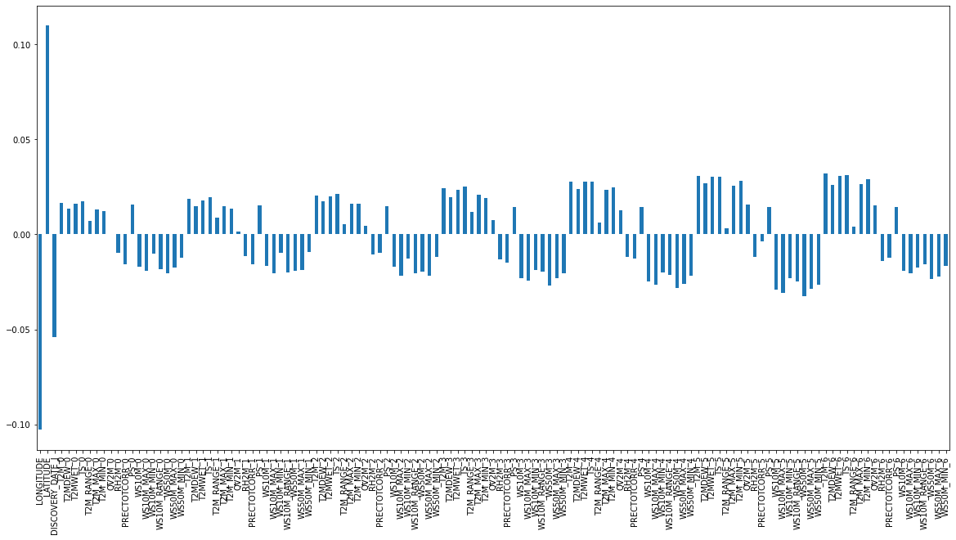

Figure - Correlation Matrix

Considering the correlation values with the dependent variable (fire_size) following columns were further dropped from the dataframe.



### Dropped Parameters Explanation

|  |  |  |
| --- | --- | --- |
| Name | Unit | Description |
| T2M_RANGE_0 | C - Celsius | Temperature at 2-meter range  (0 = present day) |
| QV2M_0 | g/kg | Specific Humidity at 2 meters  (0 = Present day) |
| QV2M_1 | g/kg | Specific Humidity at 2 meters  (1 = One day before) |
| T2M_RANGE_1 | C - Celsius | Temperature at 2-meter range  (1 = One day before) |
| QV2M_2 | g/kg | Specific Humidity at 2 meters  (2 = Two days before) |
| QV2M_3 | g/kg | Specific Humidity at 2 meters  (3 = Three days before) |
| T2M_RANGE_4 | C - Celsius | Temperature at 2-meter range  (4 = Four days before) |
| T2M_RANGE_5 | C - Celsius | Temperature at 2-meter range  (5 = Five days before) |
| PRECTOTCORR_5 | mm/day | Precipitation Corrected (Rainfall)  (5 = Five days before) |
| T2M_RANGE_6 | C - Celsius | Temperature at 2-meter range  (6 = Six days before) |

### Weather Parameters used to train the model

Please see the table below.

| Parameter | Present Day | 1 Day Prior | 2 Days Prior | 3 Days Prior | 4 Days Prior | 5 Days Prior | 6 Days Prior |
| --- | --- | --- | --- | --- | --- | --- | --- |
| Temperature at 2 Meters | NO | NO | YES | YES | NO | NO | NO |
| Dew Point at 2 Meters | YES | YES | YES | YES | YES | YES | YES |
| Wet Bulb Temperature 2m | YES | YES | YES | YES | YES | YES | YES |
| Earth Skin Temperature | YES | YES | YES | YES | YES | YES | YES |
| Temperature at 2 Meter (Max) | YES | YES | YES | YES | YES | YES | YES |
| Temperature at 2 Meter (Min) | YES | YES | YES | YES | YES | YES | YES |
| Relative Humidity at 2 Meters | YES | YES | YES | YES | YES | YES | YES |
| Precipitation Corrected | YES | YES | YES | YES | YES | NO | YES |
| Surface Pressure | YES | YES | YES | YES | YES | YES | YES |
| Specific Humidity at 2 Meters | NO | NO | NO | NO | YES | YES | YES |
| Wind Speed at 10 Meters | YES | YES | YES | YES | YES | YES | YES |
| Wind Speed at 10 Meters (Max) | YES | YES | YES | YES | YES | YES | YES |
| Wind Speed at 10 Meters (Min) | YES | YES | YES | YES | YES | YES | YES |
| Wind Speed at 50 Meters | YES | YES | YES | YES | YES | YES | YES |
| Wind Speed at 50 Meters (Max) | YES | YES | YES | YES | YES | YES | YES |
| Wind Speed at 50 Meters (Min) | YES | YES | YES | YES | YES | YES | YES |

# Weather Forecasting

The Wildfire prevention application is currently designed to predict wildfire based upon selected day’s weather dataset. The weather dataset is obtained from separate website in the application. Currently the application is only limited to selected time range which the predictions can be obtained on. The reason behind limiting the time range is because currently the application is not fitted with the function to fetch weather data for relevant day or date that are in future.

In order to address the limitation of having to fetch weather data every time and to predict future wildfire risks, possibility to design **accurate weather prediction model** has been tested as following.

## Weather forecasting model

Free to use dataset was available on ‘MeteoBlue’ web page [3]. The dataset was based in Basel a city in Switzerland. The data which were acquired were having 6 weather parameters in daily basis and hourly basis. The daily basis weather data were taken for a period of 9 years between 2010 January to 2018 December. Then the hourly basis weather taken only for 4-year period between 2015 January to 2018 December. Weather data which came as hourly basis contained 24 values per day sub-dataset for representing each hour in a day, but the daily weather data set only had the mean values regarding the parameters which were requested when downloading from web page

The RNN model has been fed only with one input at a time, but it has modelled to predict several type of forecasts such as precipitation, temperature and wind speed. The model has been fed with two set of datasets, where one set was daily record based and other with hourly record based. The model, which is built on daily data, is capable of predicting 1 day ahead of weather forecast considering past data which belongs to 3 days. The hourly based model evaluates 24 hours of past data to predict 1 hour ahead weather forecast.

The model has been built with Long Short-Term Memory (LSTM) cells included in every dense layer. Input layer consists of 120 neurons and the output layer only with 1 unit. The dense layer set with 3 layers, and 4 drop out layers were used to model both RNN models for daily and hourly dataset. Dropout layer in a RNN structure means that, if the threshold value of dropout is passed, the relevant neuron will be deactivated. Combined with this model it allows neurons, not to depend on other neurons out of order weights. Following table represent the parameters which have been selected to build the model along with training and testing dataset selection criteria.

Table - RNN Model Specification

|  |  |  |  |
| --- | --- | --- | --- |
| Layer Rank | Layer Name | Layer Size (Neurons) | Dropout Rate |
| 1 | Input Layer | 120 | - |
| 2 | Dropout Layer 1 | - | 0.2 |
| 3 | Dense Layer 1 | 120 | - |
| 4 | Dropout Layer 2 | - | 0.2 |
| 5 | Dense Layer 2 | 120 | - |
| 6 | Dropout Layer 3 | - | 0.2 |
| 7 | Dense Layer 3 | 120 | - |
| 8 | Dropout Layer 4 | - | 0.2 |
| 9 | Output Layer | 1 | - |
| Optimizer = 'Adam'; loss = 'Mean Squared Error' | | | |
| Epochs = 25; Batch size = 500 (hourly set), 100 (daily set) | | | |

Following table represents the total number of samples used to train both hourly and daily weather forecasting models along with the time-period it was taken.

Table - Dataset sizes used on RNN Model

|  |  |  |  |
| --- | --- | --- | --- |
| RNN Model | Data Type | Time Period of Dataset | Total Samples |
| Hourly based model | Training Dataset | 2017 January to December | 8736 |
| Testing Dataset | 2018 January to December | 8736 |
| Daily based model | Training Dataset | 2010 January to 2017 December | 2920 |
| Testing Dataset | 2018 January to December | 365 |

## Model Results & Evaluation

Following figures represents the prediction results and actual data for model which predicts weather one day ahead. Parameters which can be organized in a time series array has only been trained with the model.

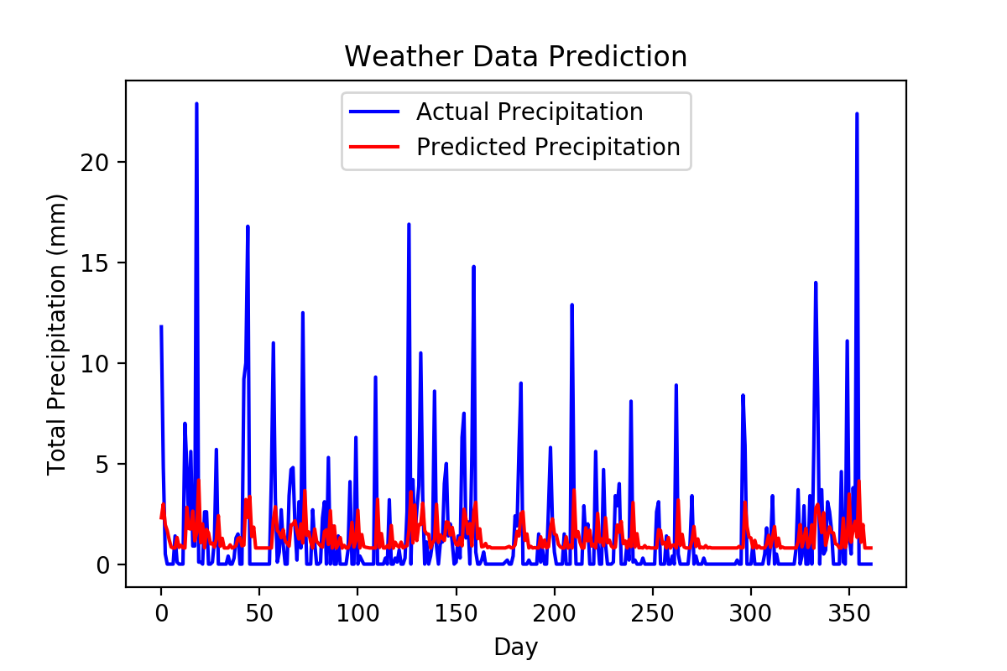

Figure - Daily Precipitation Forecast using RNN

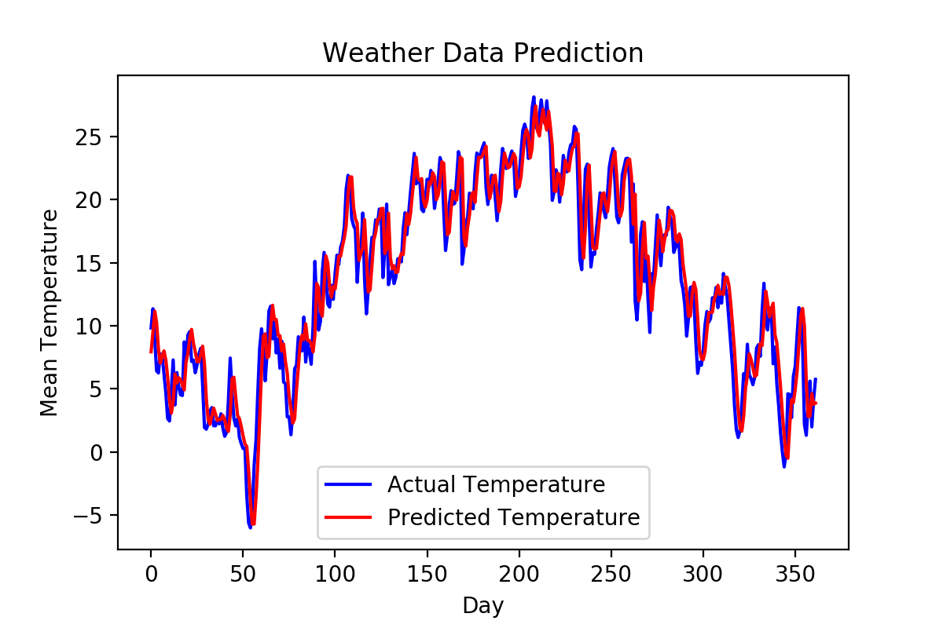

Figure - Daily Temperature Forecast using RNN

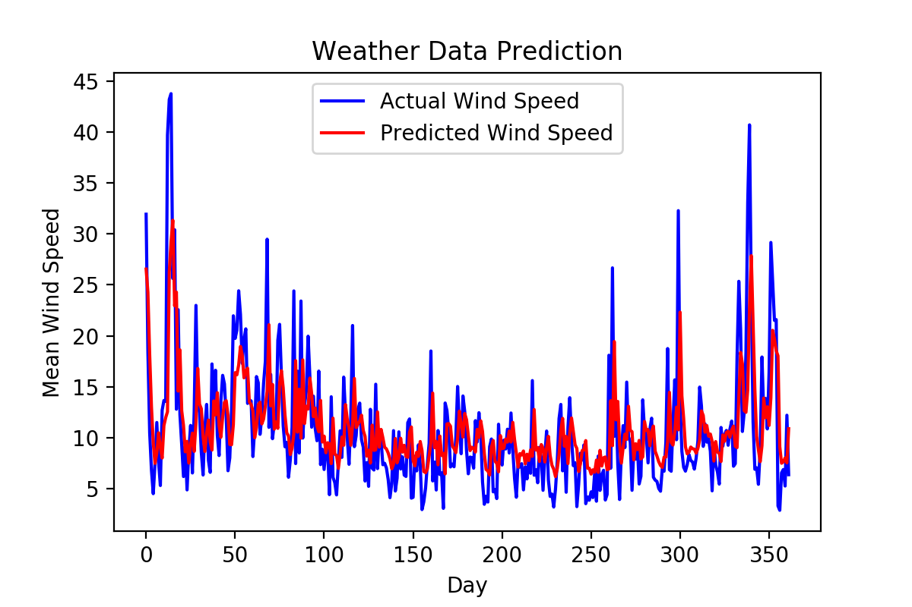

Figure - Daily Wind Speed Forecast using RNN

Following figures represents the prediction results and actual data for model which predicts relevant weather parameter one hour ahead.

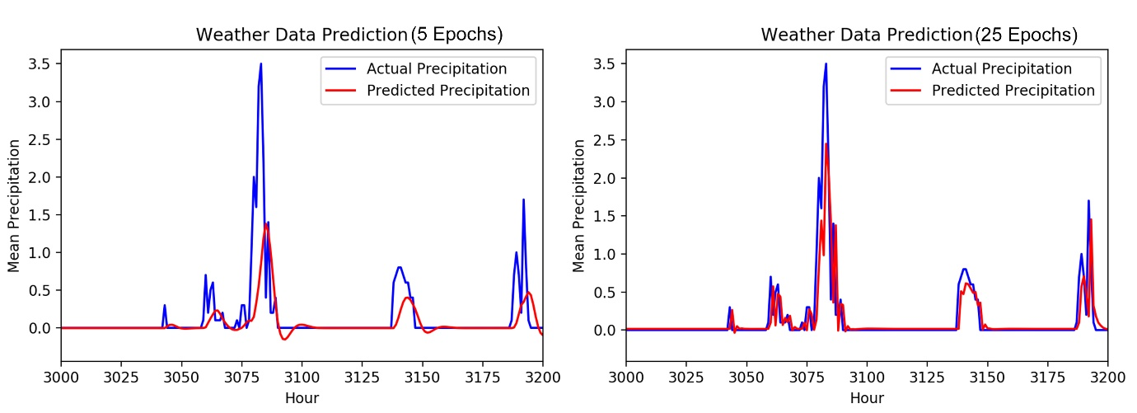

Figure - Hourly Precipitation Forecasting RNN Model

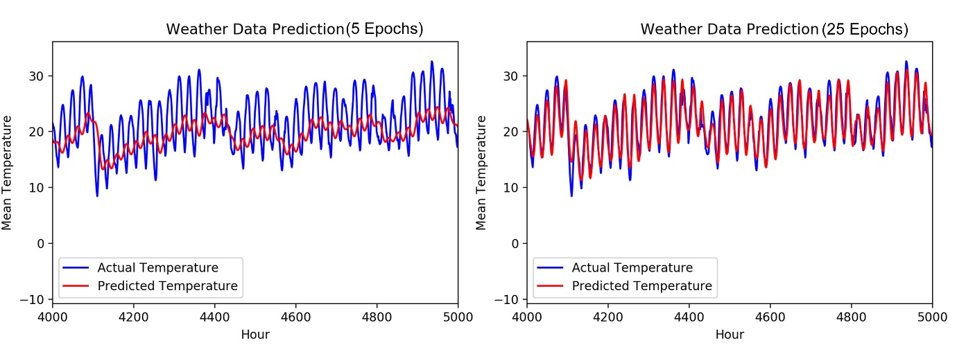

Figure - Hourly Temperature Forecasting RNN Model Comparison

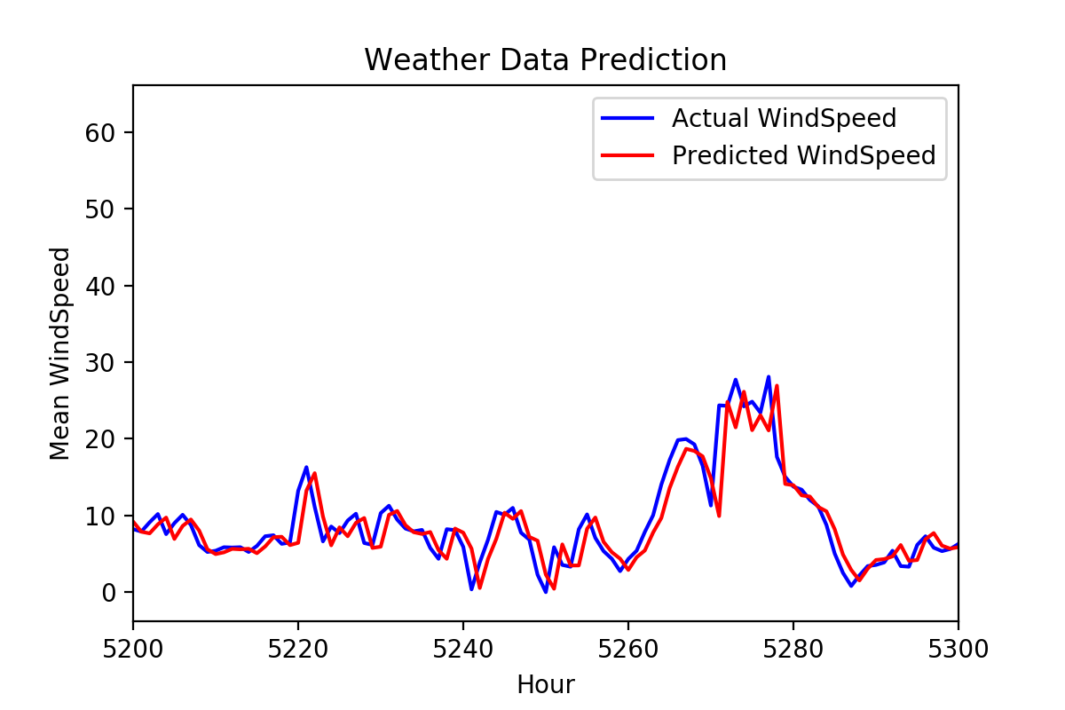

Figure - Hourly Wind Speed Forecasting using RNN [Scaled]

The Recurrent Neural Network model with LSTM cells has performed well throughout the testing phase. It has been shown that a well-trained RNN model can provide accurate results on weather forecasting. The RNN model does only consider the present and past data set to predict the behavior of the weather in future time. When comparing both daily based and hourly based models, it could be seen that the hourly predicting model, in other words short-term predicting model perform well.

## Final Thoughts on Weather Forecasting Model

However above results clearly shows that precipitation, temperature & windspeed which are in a time series form can be predicted using above model with a quite good accuracy. The issue arises when the Wildfire application requires more weather parameters which cannot be predicted with RNN model as above. **Specific humidity (g/kg)** and **precipitation (mm/day)** parameters are holding dependency with more advance metrological parameters such as cloud coverage, air pressure and require more advanced neural networks for prediction. Thus, designing a separate machine learning model dedicated to predicting weather data instead of properly utilizing a third-party service for fetching relevant weather data, could lead to less accurate result in wildfire prediction application.

# Wildfire Model Building & Training

After pre-processing the raw data, dataset was saved as a CSV file format. Then it was added to the H2O Driverless AI platform in order to determine the best suitable model and parameters.

Prior to the dataset being processed, dataset was split into train, test & validation. The percentage for each set is respectively 70%, 15% & 15%.

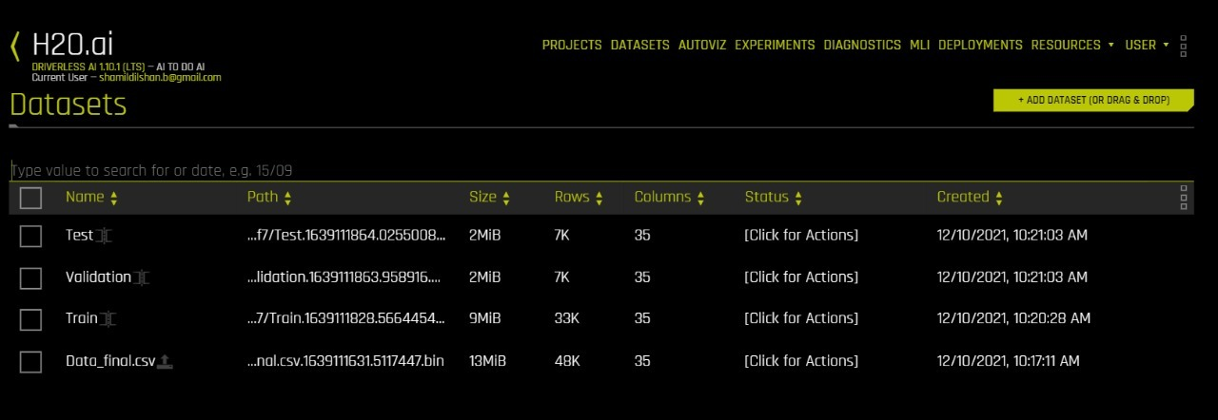

Figure - Dataset Split

After the dataset is prepared by splitting as above, an Experiment Setup was created inside the platform. Experiment setup was targeting “fire_size” column as the dependent variable and experiment type is set to “supervised”. Afterwards the experiment setup is started and following results has been obtained by the platform.

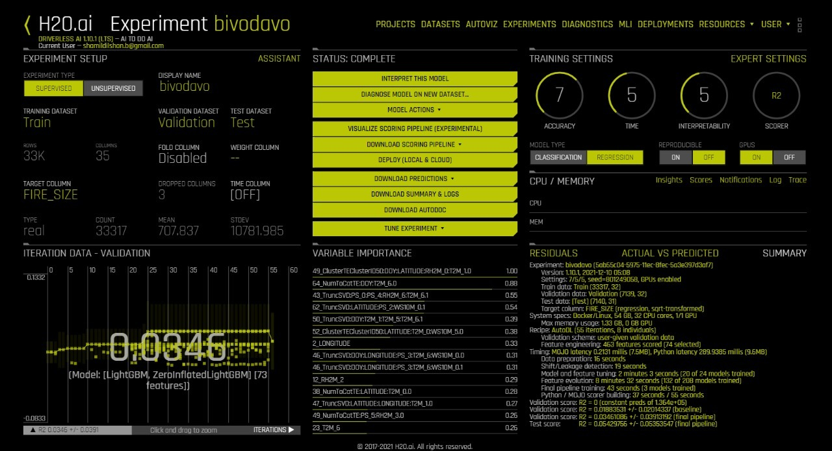

Figure - Experiment Setup Results

“Autodoc” was generated and downloaded at the end of the experiment in order to identify the performance results for each model. The document results were used to determine the best model and its hyper-parameters. The best model that was considered for model building was “LightGBM”.

The model used in the application is LightGBM which is a fast-processing algorithm. The selected model is a gradient boosting framework that makes use of tree-based learning algorithms. This algorithm grows vertically which means leaf-wise. It chooses the leaf with large loss or grows, to lower down more in the next step. One of the perspectives of choosing LightGBM as our model is its’ lightness. It takes less memory to run, can deal with a large amount of data, and give good accuracy of results.

## Pipeline

Final StackedEnsemble pipeline with ensemble_level=2 transforming 31 original features -> 74 features in each of 3 models each fit on external validation set then linearly blended:

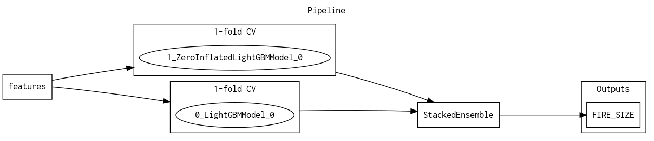

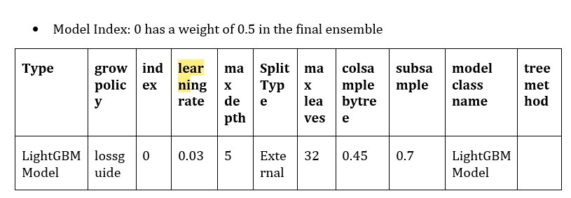

Figure - Hyper Parameter for LightGBM model

Above hyper-parameters were then utilized to build the model LGB regression model. Following code snippet represents the relevant section of the notebook which was used to create the model.

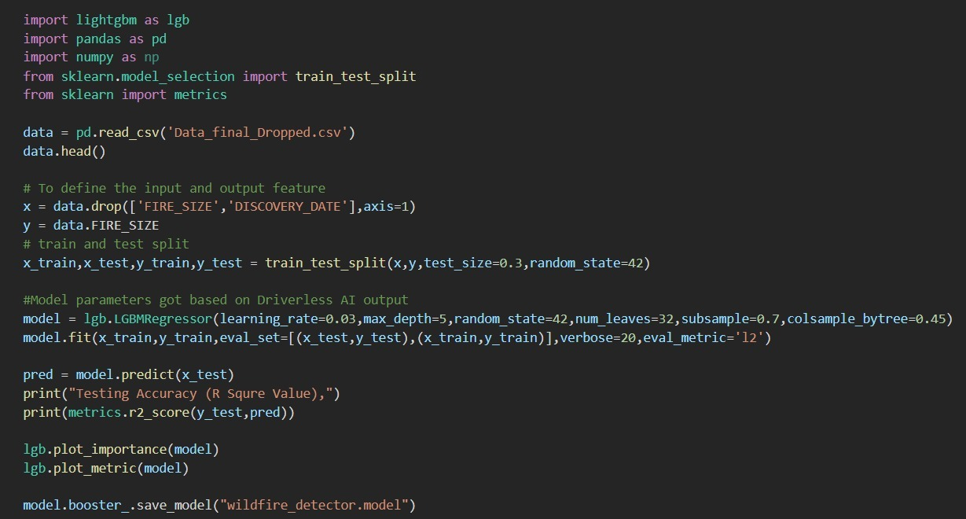

## Model Results

Following model results were taken after the model is saved. Training accuracy and testing accuracy in the following figure represents the **R2 Score.**

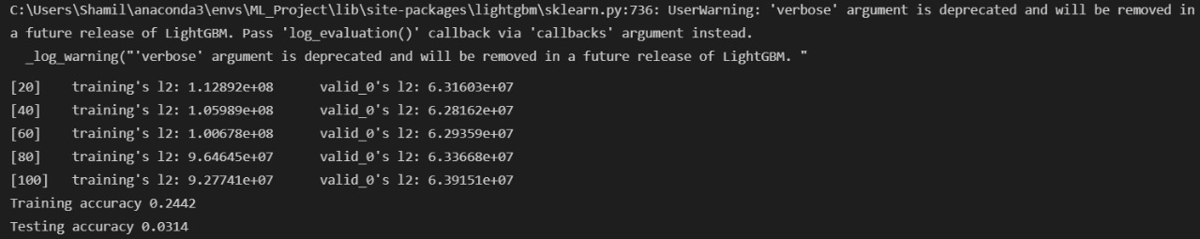

Figure - Model Results

## Performance of Final Model

|  |  |  |  |  |  |
| --- | --- | --- | --- | --- | --- |
| **Scorer** | **Better score is** | **Final ensemble scores on validation (internal or external holdout(s)) data** | **Final ensemble standard deviation on validation (internal or external holdout(s)) data** | **Final test scores** | **Final test standard deviation** |
| R2 | higher | 0.03461086 | 0.03913192 | 0.05429756 | 0.05353547 |
| GINI | higher | 0.8891321 | 0.01445112 | 0.8950952 | 0.0148617 |
| MAE | lower | 602.3961 | 101.0958 | 581.8617 | 111.8432 |
| MAPE | lower | 11580.52 | 1411.909 | 12526.36 | 1660.284 |
| MER | lower | 0 | 0.2302509 | 12.11784 | 7.080475 |
| MSE | lower | 8.128958e+07 | 5.133636e+07 | 7.805699e+07 | 5.133636e+07 |
| R2COD | higher | 0.01607631 | 0.01671084 | 0.02129041 | 0.01671084 |
| RMSE | lower | 9016.073 | 2001.861 | 8834.986 | 2335.224 |
| RMSLE | lower | 2.161031 | 0.01938655 | 2.174275 | 0.02108419 |
| RMSPE | lower | 174614.9 | 40862.74 | 218430.3 | 70200 |
| SMAPE | lower | 176.9048 | 0.5324957 | 176.7379 | 0.5324957 |

# Prediction Application

Application instance is deployed in H2O AI cloud and it can be accessed using the following URL.

* **Instance ID**: 001f7563-5768-437e-8553-b6c00f296ed2
* **URL**: <https://001f7563-5768-437e-8553-b6c00f296ed2.challenge.h2o.ai/>

## Inputs to the model

The prediction system accepts several inputs if the user needs to get predictions for a wildfire. Following image shows the user interface for inputting data which is required for the system (Model) to predict the severity parameter for the given geo-location.

Geo-Location can be viewed using the “**Mark on the Map**” or “**Converting Zip Code”** button and selecting the desired point using the graphical map of the region. After the point is selected, coordination data can be input to the system manually using Latitude & Longitude.

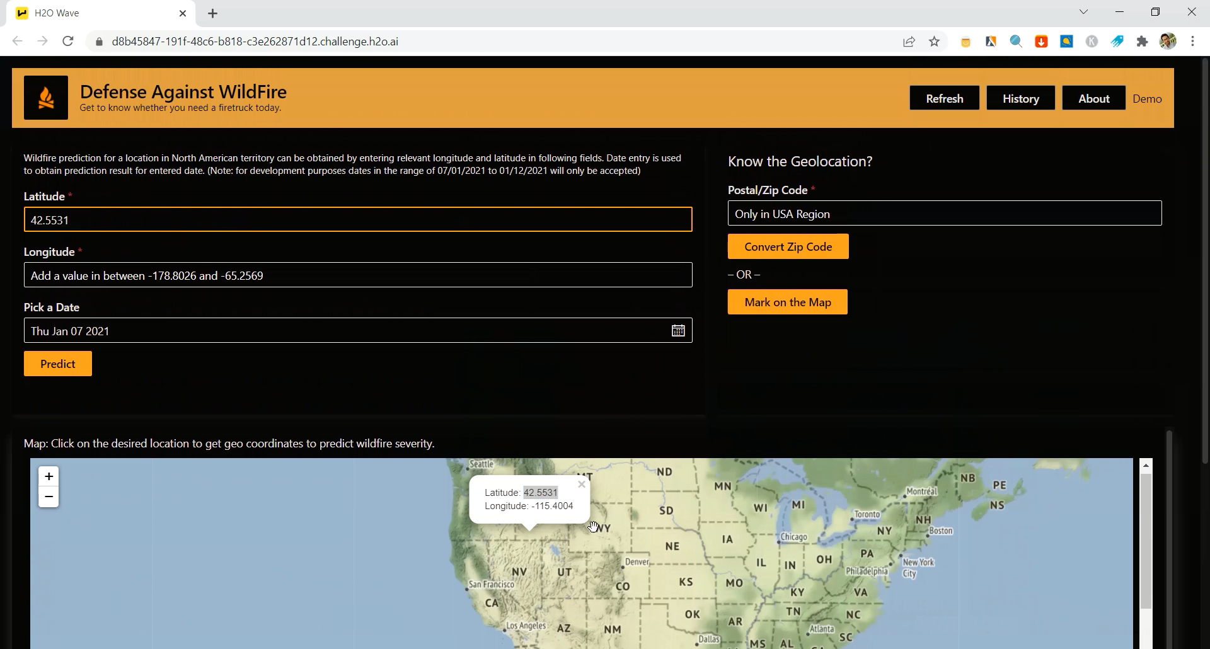

Figure - Selecting geo location using the Map

The system needs user to pick a date which the user wants the system to predict the wildfire on the desired geo-location. Ideally the above application can be modified to fetch the current date and time from the Internet therefore the user doesn’t get to input the date. Main reason the application has designed in this way manner is due to complexity in updating weather data automatically. After the user interface provide necessary values to fetch the weather data from a pre-saved dataset which is not being automatically updated.

Table - Input Parameters for the Application by User

| Parameter | Description | Input Range |
| --- | --- | --- |
| Latitude | Latitude of the geo-location | 17.9397 to 70.3306 |
| Longitude | Longitude of the geo-location | -178.8026 to  -65.2569 |
| Zip code (Optional) | Text box which accepts zip codes in the United States – Value will be converted to geo-coordinates and used as the input parameters | Valid US zip codes only |
| Date | Date to fetch the weather data from pre-saved dataset | 07/01/2021 to 01/12/2021 |

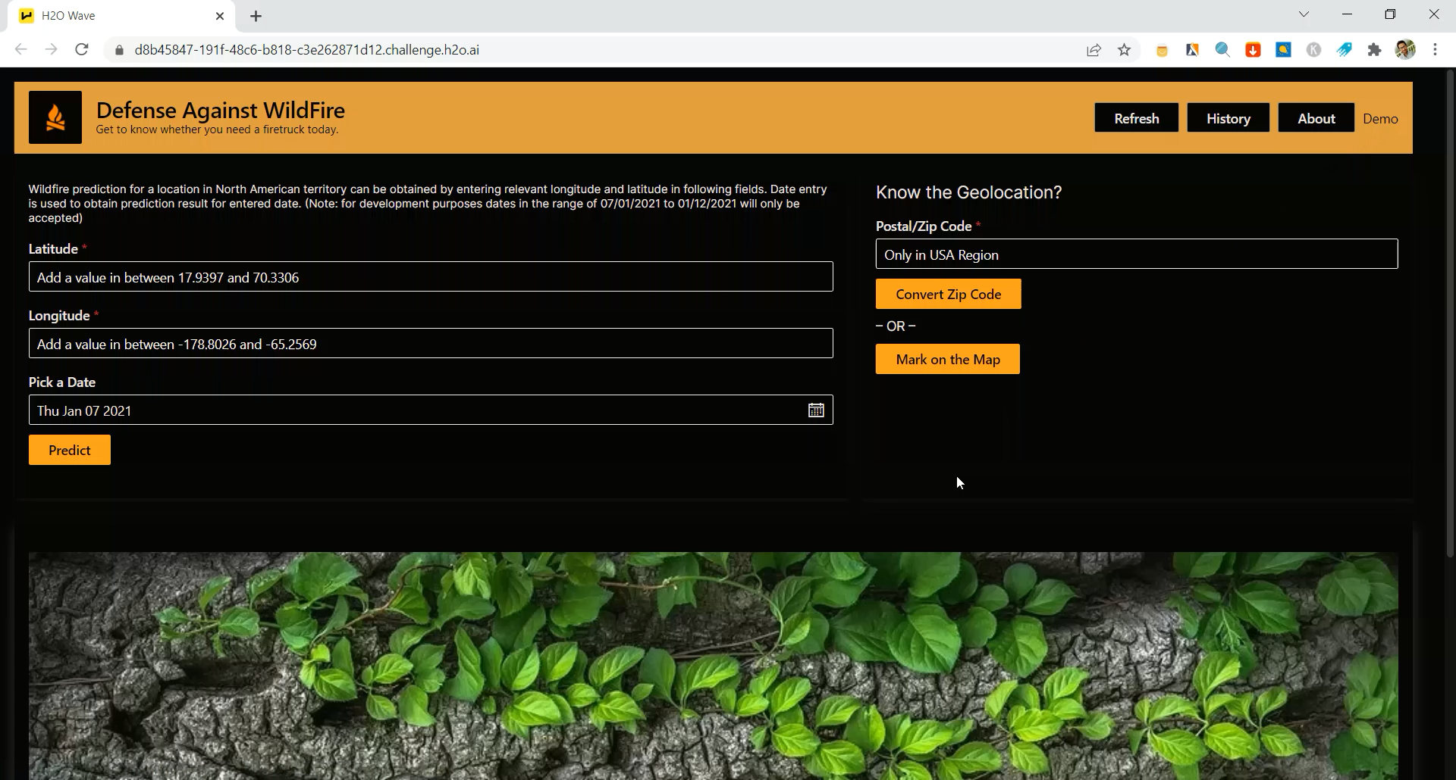

Figure - User Interface of the Application

## Features of the Application

Application user experience has been improved after the first submission was submitted on the H2O wildfire challenge. Following features are implemented and deployed in the H2O cloud instance.

### Zip/ Postal Code as the Geocode

App was initially developed where user must enter valid longitude and latitude to get predictions. A map which was shown in the bottom portion of the screen is used to select and pin the point where geo-coordinates were shown. Since this task is time consuming, a function to translate valid United States zip codes to relevant address and geo location was added.

Once the user input the zip code, app automatically inputs the longitude and latitude for the relevant text boxes and marks the geo-location on the map in the bottom half of the screen. Following figures represent the app functionality.

Note: Zip code translation was developed using Geo-Py service in the first place, but when application is deployed to H2O cloud it was having connection timeout error. As a workaround CSV file containing most of the US zip codes has been used to translate zip codes to geo-coordinates. Recently published zip codes won’t translate into coordinates with this offline method.

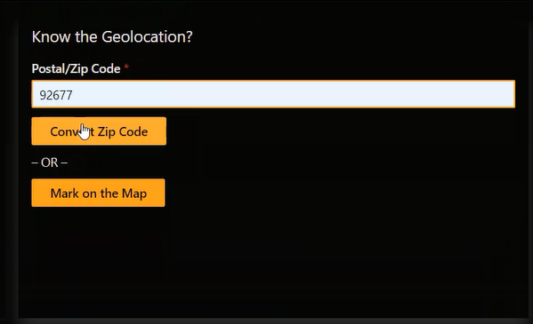

Figure - Zip code input

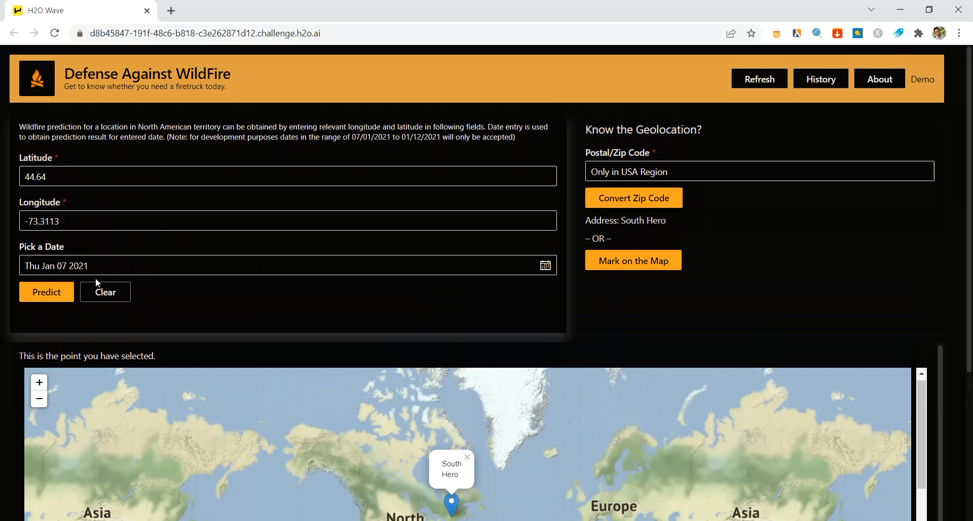

Figure - Zip Code translated to geo-location

### Prediction Location History

Once the users get the predictions from the application for a location, it is stored in the application and visualized on the map. This is allowing users to keep track of previous locations which they have looked on wildfire predictions.

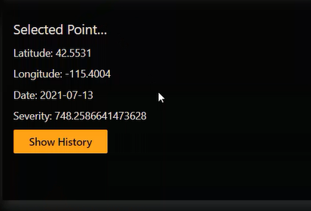

Figure - Accessing history of predictions

Each location user enters is marked on the map with a **coloured marker** demarcating the wildfire severity with colours mentioned in the following table.

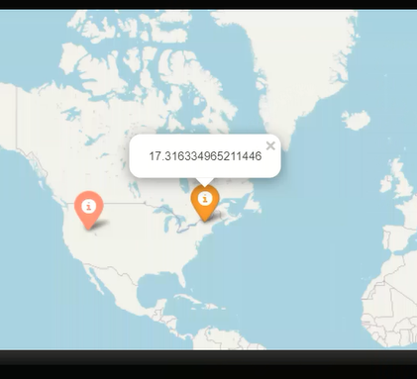

Figure - Prediction history shown on the map

Table - Fire Class and Demarcation Colour

|  |  |  |
| --- | --- | --- |
| Severity Value | Class | Class Colour |
| 0 | None | Dark Green |
| 0.1 – 0.2499 | Class A | Green |
| 0.25 – 9.99 | Class B | Light Green |
| 10 – 99.99 | Class C | Orange |
| 100 – 299.99 | Class D | Pink |
| 300 – 999.00 | Class E | Light Red |
| 1000 - 4999 | Class F | Red |
| 5000 and above | Class G | Dark Red |

### Exception Handling

The application has following set of limitations and those limitations has been checked prior the prediction result is being fetched.

1. US region dataset has ONLY been used to train the ML model thus geo-points that can be entered are only within a limited area. (Latitude: 17.9397 to 70.3306 | Longitude: -178.8026 to -65.2569)
2. Automatic LIVE weather data acquisition function has not been implemented. Hence, valid dates which can be entered to the app is from 07.01.2021 to 01.12.2021

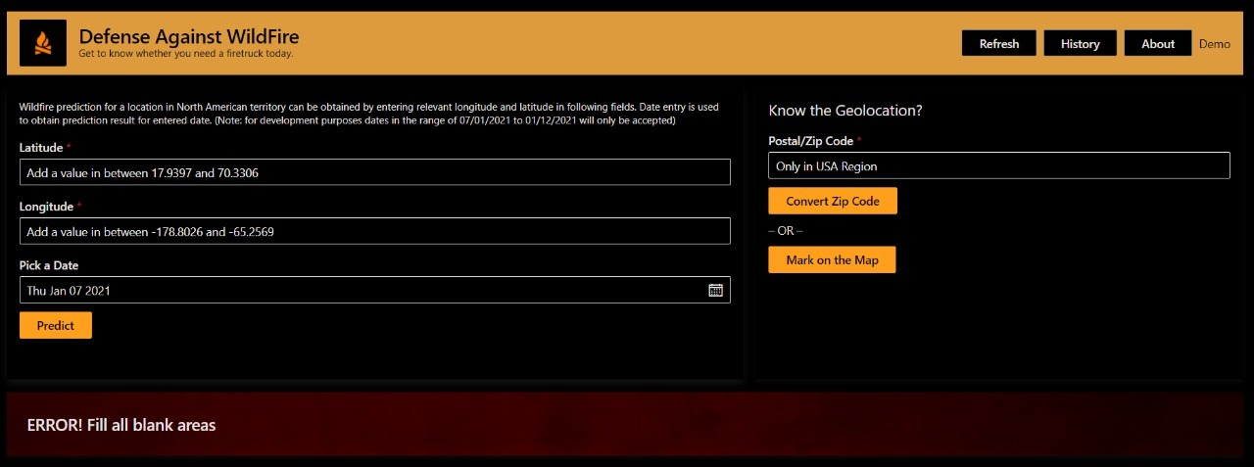

Figure - Empty input field error handler

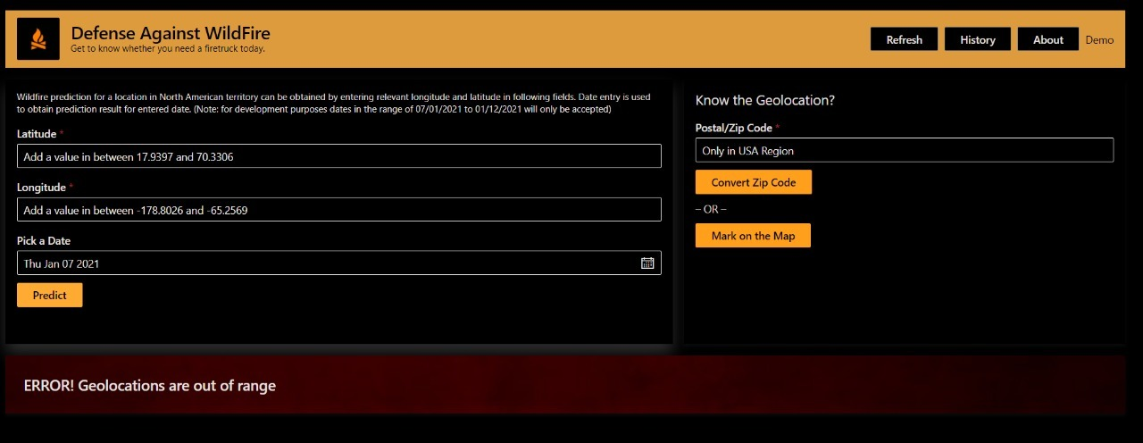

Figure - Out of range geo-location error handler

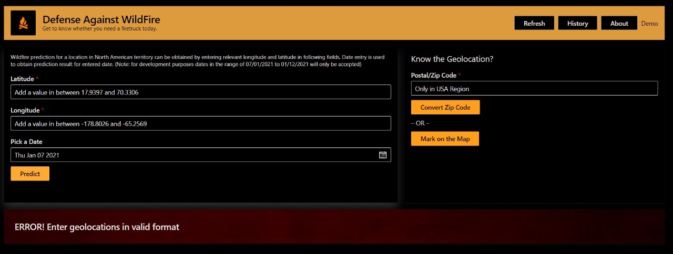

Figure - Invalid Zip/ Postal Code input error handler

### Application Optimization

The database for storing weather data for the application was initially associated with Pickle files holding on locally. The pickle file was about 800 MBs and it was taking around 10-15 seconds to load with the application on the startup process. To increase the app’s performance the database was moved in to Firebase server which has allowed the main application to load almost instantaneously.

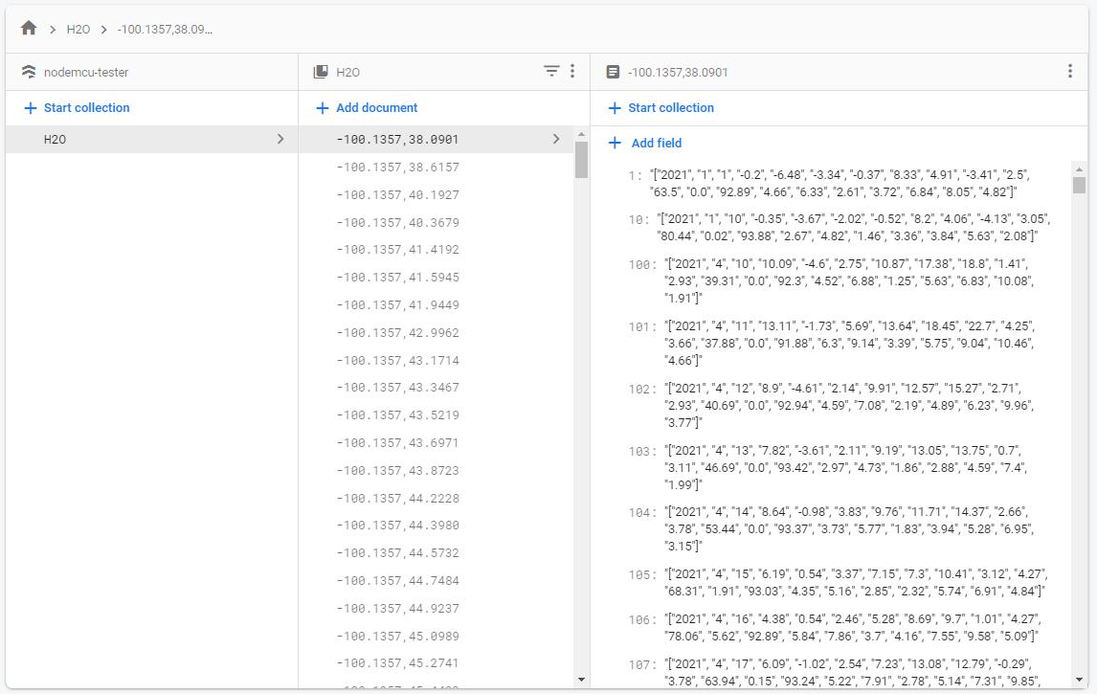

### Demo Video for New Users

Application is included with a demonstration video where the new users can view and understand the basic functionality of the application. It can be accessed through the application by clicking the “Demo” hyperlink or visiting following URL.

URL: <https://drive.google.com/file/d/1ku94g6s0lCYsipLuMcTtIOL06Sl435Ek/view?usp=sharing>

## Prediction from the Application

As the user provides necessary values to the application, model which has been trained in the application fetches the relevant weather data. The application requires weather data for past 7 days from the user picked date. Application is defined to collect all the weather data into one row and then provide them into the model.

The model out is produced as the severity value which starting from zero and zero represents that there is no risk of a wildfire event considering the geo-location and weather **data for past 7 days from the user picked date**. If there is a severity value presented it can be further understood by referring following table. (Table 5 - Wildfire Size Categorization)

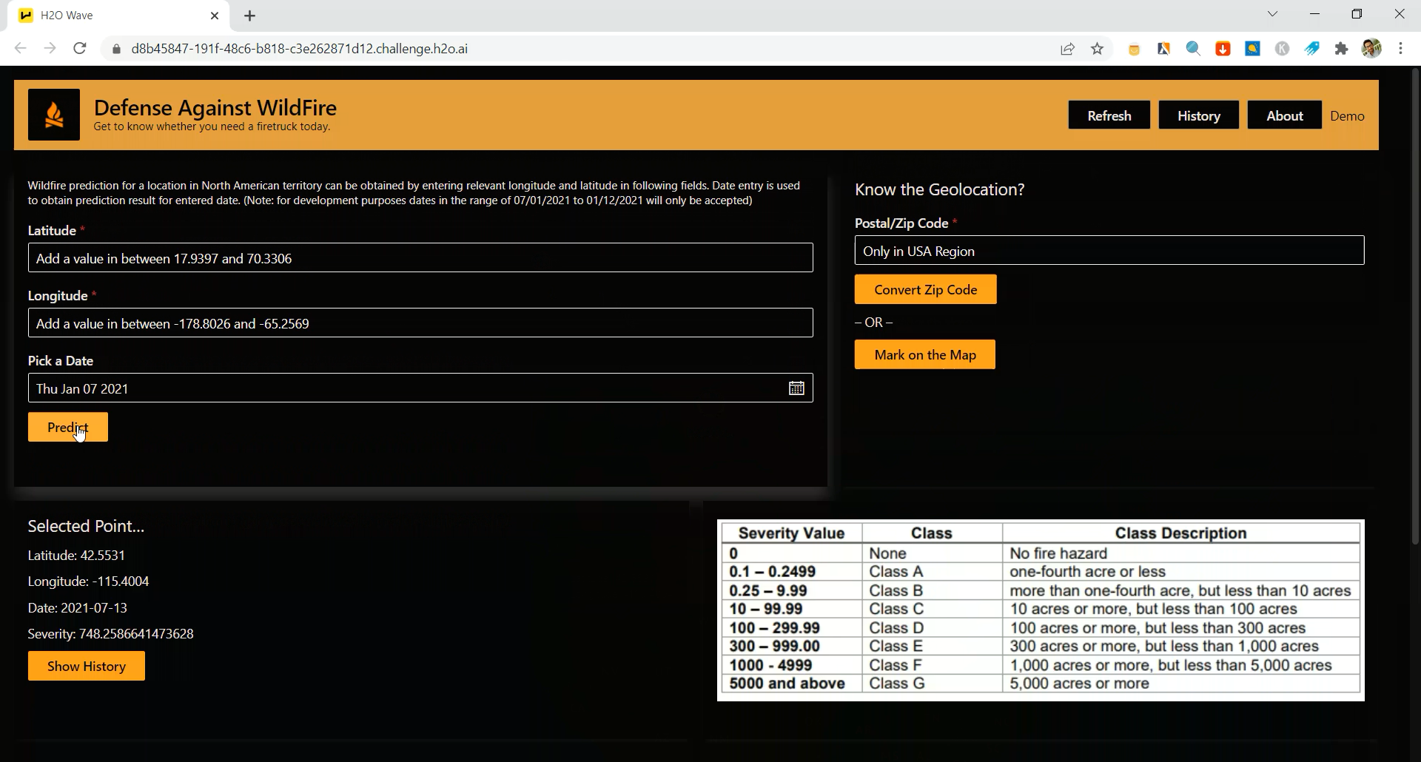

Figure - Output from the Application (Severity)

Table - Wildfire Size Categorization

|  |  |  |
| --- | --- | --- |
| Severity Value | Class | Class Description |
| 0 | None | No fire hazard |
| 0.1 – 0.2499 | Class A | one-fourth acre or less |
| 0.25 – 9.99 | Class B | more than one-fourth acre, but less than 10 acres |
| 10 – 99.99 | Class C | 10 acres or more, but less than 100 acres |
| 100 – 299.99 | Class D | 100 acres or more, but less than 300 acres |
| 300 – 999.00 | Class E | 300 acres or more, but less than 1,000 acres |
| 1000 - 4999 | Class F | 1,000 acres or more, but less than 5,000 acres |
| 5000 and above | Class G | 5,000 acres or more |

# References

|  |  |
| --- | --- |
| [1] | R. Tatman, “1.88 Million US Wildfires,” 13 05 2020. [Online]. Available: https://www.kaggle.com/rtatman/188-million-us-wildfires. |
| [2] | NASA Langley Research Center, [Online]. Available: https://power.larc.nasa.gov/data-access-viewer/. |
| [3] | Meteoblue, “MeteoBlue,” [Online]. Available: https://content.meteoblue.com/en/specifications/weather-variables/precipitation. [Accessed 20 January 2022]. |
| [4] | National Wildfire Coordinating Group, “Size Class of Fire,” [Online]. Available: https://www.nwcg.gov/term/glossary/size-class-of-fire. |